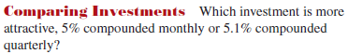

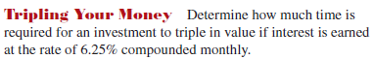

Match each graph with the correct #59, 60, 61, 62 (You should not need a calc for this)
